AI-ENABLED MARKET AND PRODUCT
INTELLIGENCE SYSTEM

AI-Driven Tobacco-Free School Verification & Monitoring System

RTGS AI Hackathon 2026
Prohibition and Excise Department
Government of Andhra Pradesh

Submitted by
AISmartLive Solutions Pvt. Ltd.
Visakhapatnam, Andhra Pradesh

20 may 2026

Section 1: Basic Information
Captures primary entity details for identification and verification.
Organization | AISMARTLIVE SOLUTIONS PVT LIMITED
Entity Type | MSME
Registration Number | 37AAWCA6687Q1Z9
Date of Registration | 13/04/2022
Official Website | https://aismartlive.com
DPIIT Recognition No. | DIPP196777
Registered Address | 50-196-13/1, BS Layout, Visakhapatnam
State / District | Visakhapatnam, Andhra Pradesh
Pin Code | 530013

Section 2: Point of Contact
The main person responsible for communication with the organizing team.
Full Name | B. YASWANTH
Designation | AI/ML ENGINEER
ssEmail ID | yaswanthbyrapuneni@gmail.com
Mobile Number | +91 6309766520

Section 3: Organization / Team Profile
Highlights who we are and what we do.

Brief Company Profile
AISmartLive Solutions Pvt. Ltd., headquartered in Visakhapatnam, is a deep-tech company focused on building AI-powered platforms for high-impact sectors such as Retail, Education, Industry 4.0, Smart Cities, and Healthcare. Established in 2022, the company integrates Generative AI, computer vision, IoT sensor fusion, AR/VR, multilingual LLMs, and cloud-native microservices to deliver real-time, scalable solutions.
AISmartLive is the parent organization behind multiple flagship brands—SenseMinds360, AlankaraAI, AstraVidya.AI, and Medhasense.AI—all built on a shared multi-modal AI backbone. The company has successfully executed pilots across schools, gated communities, jewellery retail centers, and healthcare hubs, demonstrating strong validation and practical field performance.
Driven by a multidisciplinary team of AI/ML engineers, IoT architects, full-stack developers, and UX designers, AISmartLive is committed to democratizing advanced AI for India. The organization is actively expanding to support large-scale deployments and aims to position Visakhapatnam as a major AI innovation hub.

Key Focus Areas | • Artificial Intelligence (AI/ML)  • Computer Vision & AR/VR  • IoT Sensor Fusion & Industry 4.0  • EduTech (Adaptive Learning Systems)  • HealthTech (Voice-First AI Platforms)  • RetailTech (Customer Analytics)  • Cloud Computing & Microservices
Team Size | 15 Members
Founding Year | 2022
Key Technologies | Multi-Modal Generative AI, Real-Time Computer Vision, Augmented Reality, Edge + Cloud Hybrid Processing, Multilingual LLMs (Telugu, Hindi, English), Scalable Microservices (FastAPI, Docker, Kubernetes, GCP), IoT Sensor Integration & Predictive Analytics
Notable Clients | AP Innovation Society, MSME & NRDC IP/Design Support, Jewellery Council of Andhra Pradesh, Educational Institutions (AstraVidya.AI deployments), Oxygen Towers Vizag (SenseMinds360 pilot), Retail Partners (Manchukonda Jewellery, Uma Jeweller)

Section 4: Hackathon Participation Details
Focused on the current hackathon entry

Challenge Category | AI-Powered Verification and Monitoring System for Tobacco-Free Schools
Project Title | TobaccoShield AI: Intelligent Compliance Verification Platform for Tobacco-Free Schools in Andhra Pradesh
Theme | AI for Public Health, School Safety, Geospatial Monitoring, and Compliance Verification
Department | Health, Medical & Family Welfare (HM&FW) Department, Government of Andhra Pradesh

Problem Statement Addressed
Develop an AI-powered digital verification and monitoring platform to automate the compliance assessment of “Tobacco-Free Schools” across Andhra Pradesh under the National Tobacco Control Programme (NTCP).
The system should use computer vision, geotagging, and geospatial analytics to verify mandatory tobacco-free signage, validate school locations using GPS metadata, detect tobacco-related waste or sale indicators near school premises, and provide real-time dashboards for transparent monitoring and evidence-based certification by government authorities.
Public Health Context
• Under the National Tobacco Control Programme (NTCP), schools are required to maintain Tobacco-Free School compliance standards
• Large-scale manual inspections make statewide monitoring difficult across Andhra Pradesh
• AI-driven monitoring can improve transparency, reduce fake reporting, and strengthen public health enforcement

Core Challenges We're Solving

• Manual Verification: Replacing manual inspections with AI-based verification
• Fake Reporting: Preventing fake or reused image submissions using GPS validation
• Limited Monitoring Coverage: Enabling large-scale school monitoring across Andhra Pradesh
• Lack of Real-Time Tracking: Providing live dashboards and compliance analytics
• Tobacco Waste Detection: Identifying cigarette butts and tobacco packets near schools
• Nearby Tobacco Sale Detection: Detecting tobacco sale points within restricted zones
• Inconsistent Compliance Checks: Standardizing verification using AI image analysis
• Slow Reporting Process: Automating alerts, reports, and compliance updates

AI Verification Engine

The AI verification engine combines computer vision, geospatial validation, and metadata analysis to automate compliance assessment.

Key components:
• Signboard Detection using YOLOv8 object detection
• Tobacco Waste Identification using image analytics
• GPS & GeoFence Validation for location authenticity
• EXIF Metadata Analysis for image integrity verification
• Duplicate Image Similarity Detection for fake reporting prevention
• Heatmap Analytics for district-level risk monitoring
AI-Based Image Authenticity Validation
• EXIF metadata verification for GPS and timestamp validation
• Detection of edited or tampered image metadata
• Duplicate and reused image similarity analysis
• Screenshot and internet-downloaded image detection
• Geospatial consistency validation using GPS coordinates and school geofencing

Target Implementation Scope
• Government and private schools across Andhra Pradesh
• District-level and state-level compliance monitoring
• AI-based verification of Tobacco-Free School regulations
• GPS and geofence-based image validation
• Detection of tobacco waste and nearby sale points
• Real-time dashboards and analytics for officials
• API integration with existing NTCP monitoring systems
• Scalable deployment for statewide implementation

Executive Summary
TobaccoShield AI is an AI-powered compliance intelligence platform designed to automate verification and monitoring of Tobacco-Free Schools across Andhra Pradesh under the National Tobacco Control Programme (NTCP).
The platform combines computer vision, GPS validation, geofencing, and geospatial analytics to detect mandatory signage, identify tobacco-related violations, validate inspection authenticity, and generate real-time compliance intelligence for government authorities.
The system uses computer vision, GPS validation, geospatial analytics, and real-time dashboards to verify mandatory tobacco-free signage, detect tobacco-related waste near schools, and validate image authenticity through geotagging and AI-based verification.
The platform helps reduce manual inspections, prevent fake reporting, and enable transparent, data-driven monitoring for district- and state-level authorities. By combining AI automation with geospatial intelligence, the solution aims to improve public health, strengthen school safety, and support effective enforcement of tobacco-control regulations across the state.

Key Value Propositions
• AI-driven automated verification of Tobacco-Free School compliance
• Faster and more transparent monitoring process
• GPS and geofence-based validation to prevent fake reporting
• Real-time dashboards for district and state authorities
• AI detection of tobacco waste and nearby sale points
• Scalable statewide monitoring across Andhra Pradesh
• Automated alerts, reports, and compliance analytics
• Improved public health and safer school environments
Unique Innovation Features
• Offline-first inspection mode for rural and low-network areas
• AI-powered district risk heatmaps for identifying high-violation zones
• Privacy-preserving face blur AI for ethical compliance monitoring
• Automated compliance scoring system for faster government decision-making
• Tamper-resistant image validation using metadata and geospatial verification

Proof of Concept Success Metrics
• Accuracy of AI-based signage detection
• Percentage of correctly GPS-validated image uploads
• Reduction in manual verification effort
• Detection rate of tobacco waste and violation indicators
• Number of schools successfully verified through the platform
• Real-time dashboard response and monitoring efficiency
• Reduction in fake or invalid image submissions
• Improvement in compliance tracking across districts
• Scalability and performance across multiple schools simultaneously

Problem Statement Analysis

1.Current Operational Challenges

School Monitoring Context

• Thousands of government and private schools across Andhra Pradesh
• Manual inspection and self-reporting based compliance verification
• Wide variation in school environments across urban, semi-urban, and rural areas
• Difficulty in monitoring tobacco-free compliance at large scale
• Presence of tobacco sale points and tobacco waste near some school zones
• Lack of real-time visibility into district-wise compliance status
• Inconsistent verification methods leading to reporting inaccuracies
• Delayed reporting and limited evidence-based monitoring system

Critical Pain Points

A. Manual Verification Challenges

• Manual inspection process without AI-based automation
• Difficulty in verifying compliance across thousands of schools
• Limited ability to identify violations in real time
• Lack of standardized digital verification methods

B. Poor Monitoring & Analytics

• Limited use of image and geospatial data for compliance analysis
• No centralized visibility into district-wise school compliance
• Lack of real-time monitoring dashboards and analytics
• Missing actionable insights for government authorities

C. Fake Reporting & Validation Issues
• Possibility of fake, edited, or reused image submissions
• Difficulty in validating actual school locations
• Lack of GPS and geofence-based verification systems
• Delayed detection of invalid or misleading reports
D. Limited Visibility Around School Zones
• Difficulty in identifying tobacco waste near schools
• Lack of monitoring of nearby tobacco sale points
• No automated detection of high-risk tobacco zones
• Limited surveillance of restricted 100-yard areas
E. Inefficient Compliance Management
• Slow reporting and approval processes
• Lack of automated alerts and compliance tracking
• Inconsistent verification methods across regions
• Limited scalability for statewide implementation

Solution Overview: TobaccoShield AI Platform

Platform Architecture

TobaccoShield AI operates through multiple integrated intelligence layers designed to automate compliance verification, improve monitoring transparency, and strengthen Tobacco-Free School enforcement across Andhra Pradesh.

Technical Architecture

System Architecture Diagram
The TobaccoShield AI platform follows a multi-layer architecture designed for automated school compliance verification and real-time monitoring.
Field inspectors or school authorities upload geo-tagged images through the web or mobile application. The backend system validates GPS coordinates and checks whether the uploaded images fall within the predefined school geofence boundaries.
The AI processing layer uses computer vision models to detect mandatory Tobacco-Free School signage, identify tobacco-related waste near school premises, and validate image authenticity through metadata and similarity analysis.
Validated inspection data is securely stored in the central database and processed for analytics generation. The dashboard layer provides district- and state-level authorities with real-time compliance status, heatmaps, alerts, and violation monitoring tools.
The architecture is designed to support scalable deployment across schools in Andhra Pradesh while ensuring transparency, auditability, and efficient compliance tracking under the National Tobacco Control Programme (NTCP).

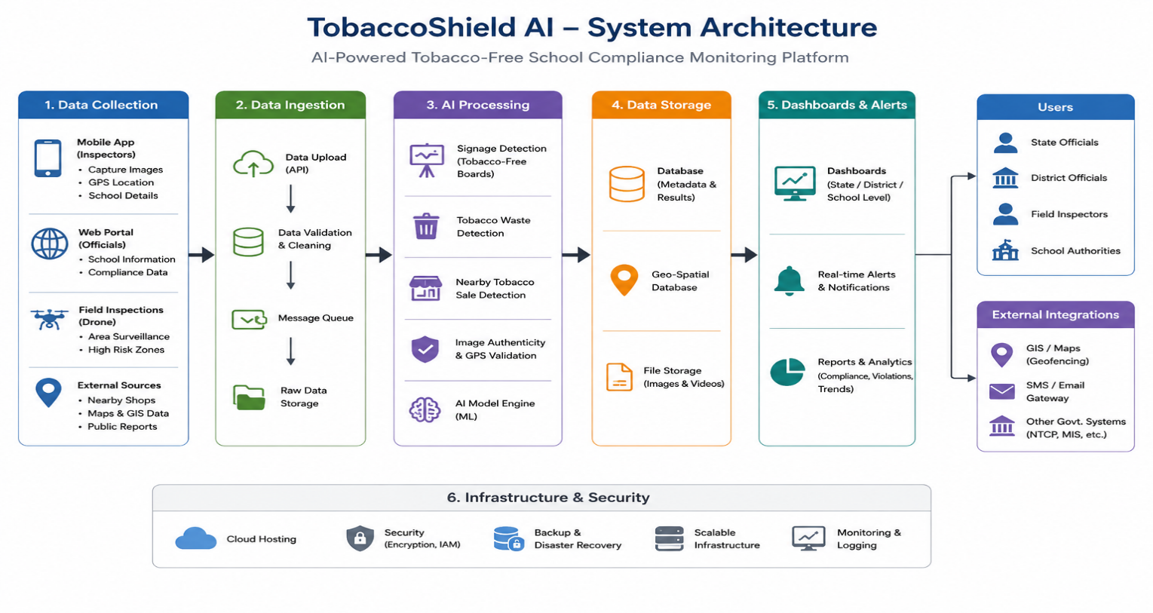

Core System Capabilities

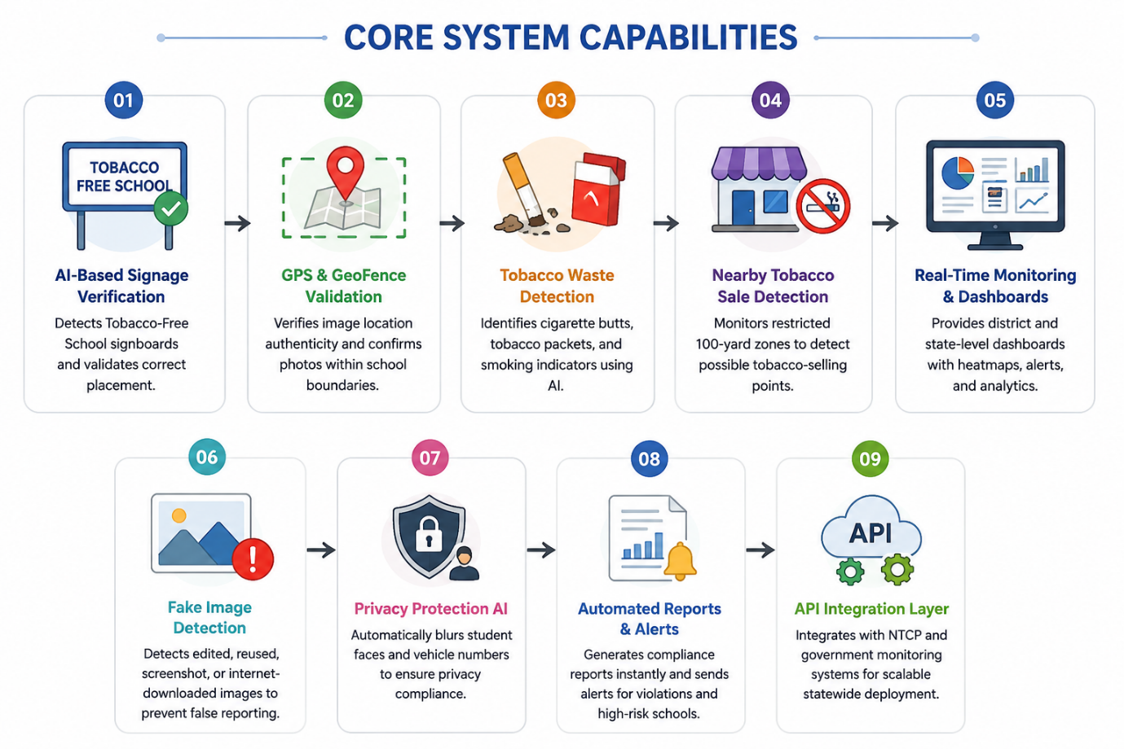

End-to-End Data Flow Diagram

The data flow begins when inspectors upload school inspection images along with GPS-enabled metadata through the mobile or web platform.
The validation engine verifies image authenticity, timestamp consistency, and geofence alignment with registered school locations. AI models then process the uploaded images to detect required signage, tobacco-related violations, and suspicious or reused images.
Processed results are stored in the centralized database and forwarded to the analytics engine for compliance scoring and district-level monitoring. Real-time dashboards and alerts enable government officials to monitor school compliance, identify high-risk zones, and take corrective actions efficiently.
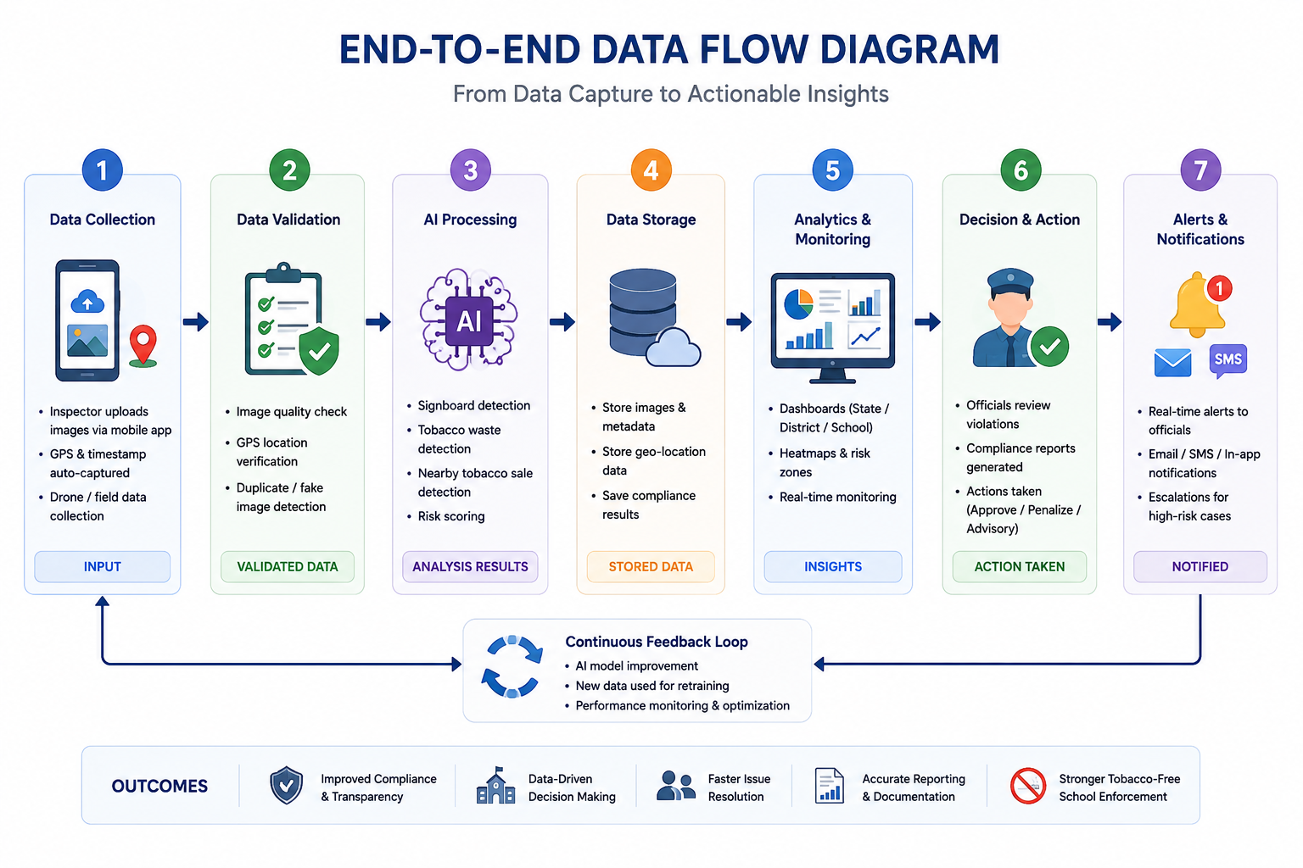

Technology Stack

Category | Technologies
AI & Image Detection | Python, YOLOv8, OpenCV
Frontend | React.js
Backend | FastAPI
Database | PostgreSQL
Maps & GPS | Google Maps API
Cloud & Deployment | Docker, AWS
Authentication | JWT Authentication
Alerts & Notifications | Twilio, Email AP
Dashboards & Analytics | chart.js

Implementation Strategy

Phase 1: Foundation (Weeks 1–2)
- Requirement Analysis: Understand NTCP compliance rules and school verification requirements
- Infrastructure Setup: Configure backend, database, cloud, and APIs
- Data Collection: Gather school images, GPS data, and sample datasets
- Data Preparation: Clean and organize image and location data
- Model Preparation: Prepare datasets for AI model training and testing

Phase 2: AI Model Development (Weeks 3–5)
- Signage Detection Model: Train AI to detect Tobacco-Free School signboards
- Tobacco Waste Detection: Detect cigarette butts and tobacco packets using computer vision
- GPS & Geofence Validation: Implement location verification system
- Fake Image Detection: Identify edited, reused, or invalid image uploads
- Model Testing & Optimization: Improve accuracy and reduce false detections

Phase 3: Application Development (Weeks 6–8)
- Backend Development: Build APIs and verification services using FastAPI
- Dashboard Development: Create real-time monitoring dashboard using React.js
- Alert System: Implement email/SMS notifications for violations
- User Authentication: Add secure login and role-based access
- Database Integration: Store compliance data, images, and analytics

Phase 4: Integration & Testing (Weeks 9–10)
- AI Integration: Connect AI models with frontend and backend systems
- End-to-End Testing: Test image upload, GPS validation, and dashboard workflows
- Performance Testing: Optimize system speed and scalability
- Security Testing: Ensure secure data handling and authentication
- User Feedback & Improvements: Refine system based on testing results

Phase 5: Pilot Deployment (Weeks 11–12)
- Pilot Launch: Deploy system in selected schools/districts
- User Training: Train inspectors and officials on platform usage
- Real-Time Monitoring: Track compliance and AI performance
- Feedback Collection: Gather observations from field users
- System Optimization: Improve features based on pilot feedback

Phase 6: Evaluation & Scaling (Weeks 13–14)
- Success Metrics Evaluation: Measure AI accuracy and monitoring efficiency
- Documentation: Prepare technical documents and user guides
- API Integration: Connect with NTCP monitoring systems
- Statewide Rollout Planning: Prepare deployment strategy for Andhra Pradesh
- Final presentation: Demonstrate results ,analytics and future roadmap

Success Metrics & Expected Impact

Proof of Concept Success Criteria

Metric | Target
AI Detection Accuracy | ≥92% accuracy in detecting violations
GPS Verification Accuracy | ≥95% location validation accuracy
Fake Image Detection | ≥90% accuracy in identifying invalid uploads
Manual Verification Reduction | 60–70% reduction in manual effort
Alert Response Time | Notifications generated within 30 seconds
System Uptime | 99.5% availability during pilot
User Satisfaction | ≥85% positive feedback from officials
Inspection Processing Time | ≤15 seconds per inspection

Expected Impact

For Government & Health Departments
- Improved enforcement of Tobacco-Free School regulations
- Faster identification of violations through AI monitoring
- Reduced manual inspection workload and operational costs
- Real-time compliance tracking and analytics
- Better decision-making through data-driven insights

For Schools
- Increased compliance with NTCP guidelines
- Improved campus cleanliness and safety
- Faster corrective actions through automated alerts
- Digital compliance records for audits and monitoring

For Inspectors & Field Officers
- Simplified inspection and reporting process
- Reduced paperwork and manual verification effort
- Real-time dashboard access and automated evidence collection
- Improved transparency through GPS-based validation

For Public Health & Communities
- Safer and healthier school environments
- Reduced tobacco exposure around educational institutions
- Increased awareness of tobacco-free policies
- Stronger implementation of public health initiatives

Project Timeline & Milestones
Phase | Key Activities | Deliverables
Week 1-2 | Requirement analysis, infrastructure setup, data collection, dataset preparation | Requirement document, prepared datasets, configured cloud/database setup
Week 3-5 | AI model training, signage detection, tobacco waste detection, GPS validation | Trained AI models, validation reports, optimized detection system
Week 6-8 | Backend APIs, dashboard development, authentication, alert system | Functional web dashboard, REST APIs, notification system
Week 9-10 | System integration, end-to-end testing, security & performance testing | Integrated platform, test reports, optimized system
Week 11-12 | Pilot deployment, user training, real-time monitoring | Live pilot deployment, trained users, monitoring reports
Week 13-14 | Evaluation, documentation, scaling strategy, final presentation | Success metrics report, technical documentation, rollout roadmap

Relevant Project Experience

AlankaraAI - Jewelry Virtual Try-On Platform
- Production AI platform serving 500+ users with real-time computer vision
- Emotion recognition achieving 85% accuracy at 60 FPS
- Cloud deployment experience on AWS with scalable microservices
- Demonstrated capability in production ML systems and user-facing applications

SenseMinds360 - Industrial Safety Prediction
- AI-driven predictive safety intelligence for manufacturing sectors
- Real-time analytics and anomaly detection from sensor data
- Multi-site deployment experience across industrial clusters

Government Project Experience
- Collaborations with AP Innovation Society for state-level validation
- Understanding of government workflows, compliance requirements, and stakeholder management
- Experience in pilot deployments and phased rollouts

Technical Strengths Aligned with Challenge
- Proven ML expertise in forecasting, clustering, anomaly detection
- Production-grade cloud-native architecture and deployment experience
- Real-time data processing and visualization capabilities
- API integration experience with external systems
- Mobile and web application development for diverse user bases
- Strong data engineering and ETL pipeline development
- Government project execution and stakeholder communication

